Data Parser - User Guide

1. Configuration files

Note:
Both configuration files should be saved using UTF-8 encoding.
This usually happens automatically, especially if provided templates are used.

dice.csv
Contains two columns:
Size – size of the sample in μm
Dice – list of corresponding dice, separated by comma (with space)

Example:
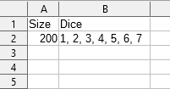

Multiple rows for different sizes can be present;
The script will automatically read correct row based on size listed in config.

config.csv
Contains five columns:
Path – relative location of the unit cell folders (i.e. folders D0, D1, etc.); Make sure it ends with a backslash \ and starts with none. If the script is placed next to the data folders – leave it empty.
Size – size of the samples to parse, in μm
Voltage – Voltage value to look at
CurrentMin – minimum allowed Current for specified Voltage
CurrentMax – maximum allowed Current for specified Voltage

Example:
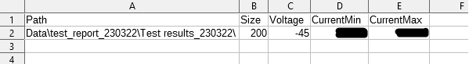
Only one row is expected.

In this example, the script and its configuration files are placed next to the Data folder.

2. Setting up Python

Make sure that the following Python libraries are installed:
pandas

Command to install a library (execute in Windows command line, aka cmd):
python3 -m pip install <library name>

For example:
python3 -m pip install pandas

3. Running the script

Execute the script in command line:
python3 <script name>

Such as:
python3 data_parser.py

Some common errors will be typed plainly in the first line after the script call, for example:

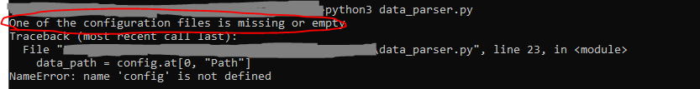
4. Output

If the script runs successfully – it produces two files:
True.csv – list of all dice that passed the Current check
False.csv – list of all dice that failed the Current check

In both files, the following data is listed in a table format:

Unit Cell – unit cell folder name
Die – die folder name
Size (will be the same for all rows, as defined in config.csv)
Voltage (will be the same for all rows, as defined in config.csv)
Abs Current – absolute value of the current for specified Voltage; empty if not measured
Report – True when Current check has passed, False otherwise

Example:
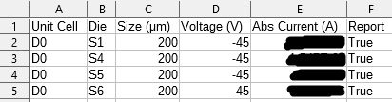

If script successfully executed but no data was found – the script will delete old output files.

